**PROJECT REPORT**

**On**

**Air Quality Index Detector Wrist Band**

**To**

**Department of Engineering**



Session 2017-2018

Submitted To Submitted by

Mr. Umesh Dutta Gagan Yadav

(Professor) Saurabh Chahal

Deepak Rana

Mukul SIngh

Department of Computer Science Engineering

ACKNOWLEDGEMENT

We would like to express my appreciation and thanks to my supervisor

For his many helpful comments and suggestion, Prof.Umesh Dutta,

The person who takes care of us during the entire project.

Last but not least, W e wish to express our thanks to any person who

Helped us by any way (given advices, consultation……….etc),

Finally, we like to greatly thank the academic staff of the School of

Engineering, Design and technology in the Manav Rachna University

Of Faridabad for their help.

CERTIFICATE

This is to certify that Mr. Gagan Yadav, Mr. Mukul Singh. , Mr Deepak Rana, and Mr. Saurabh Chahal, students of 1st year, Computer Science, Bachelor of Technology, Manav Rachna University has undergone summer training at IOT center, Manav Rachna University, Faridabad from 6th June 2018 to 20th June 2018 under the overall guidance of Prof. Umesh Dutta.

.All the above mentioned students has successfully completed their training and submitted the training project report. During the period of training they was found sincere, punctual and regular. Their conduct and behavior was very good.

SIGNATURE OF THE GUIDE-

NAME

DESIGNATION-

DEPARTMENT-

TABLE OF CONTENTS

Acknowledgement……………………………………………………………………………….1

Certificate…………………………………………………………………………………………….2

Table of contents…………………………………………………………………………………3

List of figures………………………………………………………………………………………..4

List of tables………………………………………………………………………………………..5

Abstract……………………………………………………………………………………………….6

Introduction………………………………………………………………………………………..7

Charts: Gantt chart, bill of material………………………………………………………8

Theory………………………………………………………………………………………………….9

Circuit diagram……………………………………………………………………………………10

S/w algorithm and flow chart (for app and hardware)………………………….11

Code for app and hardware…………………………………………………………………12

Simulation testing………………………………………………………………………………..13

Conclusion and future scope………………………………………………………………..14

Project links………………………………………………………………………………………….15

LIST OF FIGURES

Descriptions page

Figure 1 Air quality index table

Figure 2 Block Diagram

Figure 3 Gantt chart

Figure 4 Arduino Nano

Figure 5 MQ135 Gas Sensor diagram

Figure 6 HC06 Bluetooth diagram

Figure 7 User interface of Ubidots

List of tables

|  |  |  |
| --- | --- | --- |
| Table.no | Description | Page.no |
| Table 1. | Air quality index analyser |  |
| Table 2. | Bill of materials |  |
| Table 3. | Components needed |  |

ABSTRACT

The level of population has increased with times by lot of factors, like the increase

In population, increased vehicle use, industrialization and urbanization which

Results in harmful effects on human well-being by directly affecting health of

Population exposed to it.

Every year there is increase in the number of patient of respiratory diseases. More than 4 million peoples die due to the respiratory problem. Many of these life can be saved by only monitoring the pollution level.

This device does the same for these peoples. Many lives can be protected by this device.

INTRODUCTION

The main objective of air quality detector wrist band is that the Air is a growing issue these days. It is necessary to monitor air quality and keep it under control for a better future and healthy living for all. Due to urbanization and with the increase in the vehicles on road the atmospheric conditions have considerably affected. Harmful effects of pollution include mild allergic reaction such as irritation of the throat, eye and nose as well as some serious problems like bronchitis, heart diseases, pneumonia, lungs and aggravated sound pollution concentrations.

We propose an air quality index system that allows us to monitor and check live air quality pollution in an area. System uses air sensor (MQ135) to sense presence of harmful gases in the air and constantly transmit this data. The sensor interact

With arduino which processes this data and transmit it over the application.

This allows the authorities to monitor air pollution in different areas and act against it.

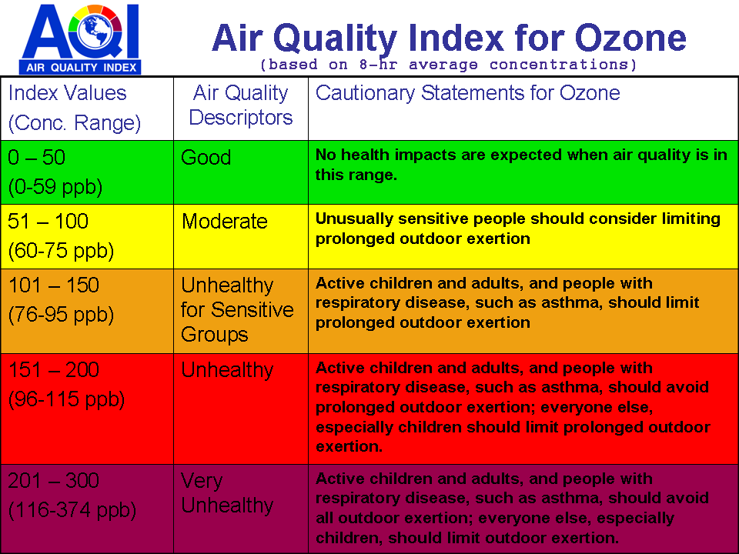

**Figure.1**

|  |
| --- |
| ARDUINO  Nano |

BLOCK DIAGRAM

|  |
| --- |
| HC06Bluetooth |

|  |
| --- |
| MQ135  Sensor |

|  |
| --- |
| Battery |

|  |
| --- |
| OLED |

Figure.2

Gantt chart

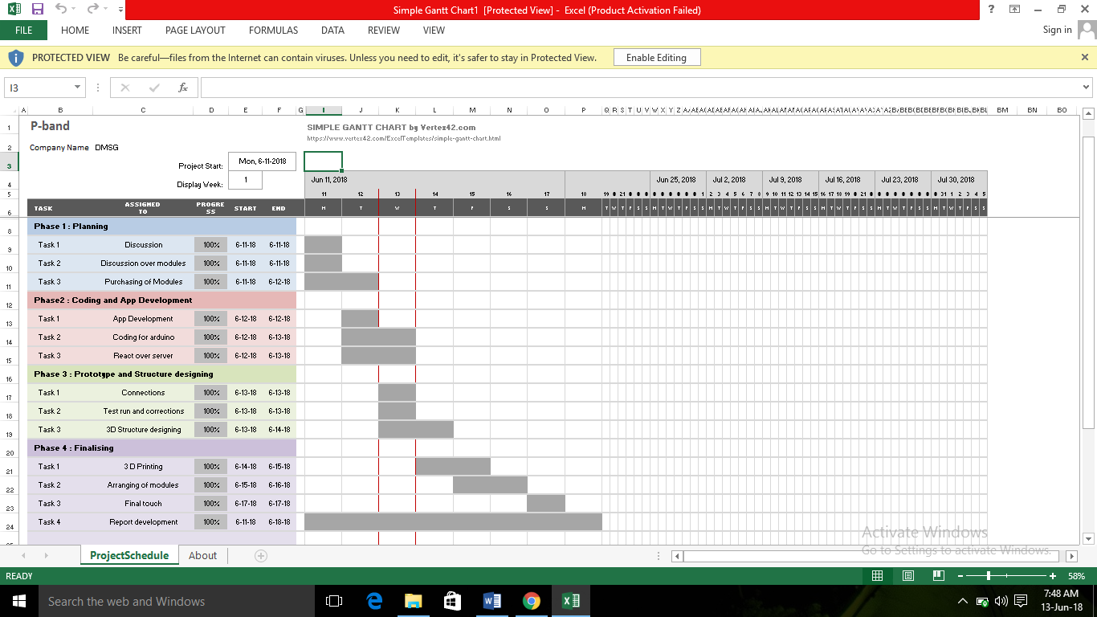

Figure.3

BILL OF MATERIALS

|  |  |  |
| --- | --- | --- |
| S.NO | PRODUCT | PRICE |
| 1. | Arduino nano | Rs. 340 |
| 2. | HC06 bluetooth module | Rs. 350 |
| 3. | OLED (64*128) | Rs. 540 |
| 4. | MQ 135 gas sensor | Rs. 450 |
| 5. | 3.7V Battery *2 | Rs. 400 |
|  | **Total** | Rs. 2080 |

Table.2

**THEORY**

The different type of components that we use throughout the project are discussed below:

* **Arduino nano**

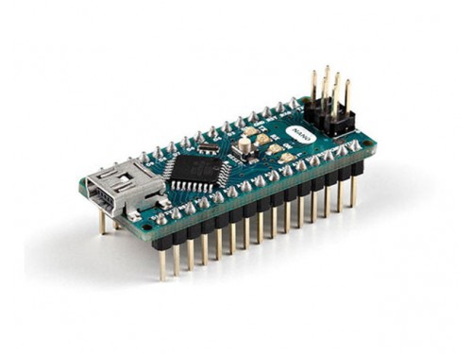

Figure.4

The Arduino Leonardo is a microcontroller board based on the ATmega32u4 (datasheet). It has 20 digital input and output pins in which can be used output and 12 as analog inputs, a 16MHz crystal oscillator, a micro USB connection, a power jack, an ICSP header, and a reset button. It contains everything needed to support the microcontroller; simply connect it with laptop with USB cable or power it with a battery to get started.

* **MQ135 Gas Sensor**

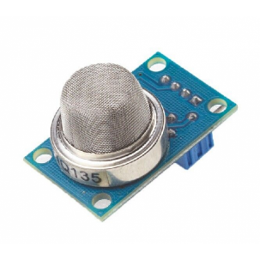

Figure.5

The sensitive material used in MQ135 gas sensor is SnO2.

The conductivity of this material is lower in clean air. The sensor conductivity increases with the increasing concentration of target pollution gas. MQ135 can monitor different kinds of toxic gases such pas sulphide, ammonium as, benzene series steam and CO2. The detection range is 10-10000ppm with the voltage rate of about 5.0Vac or DC.

* **HC06 Bluethooth module**

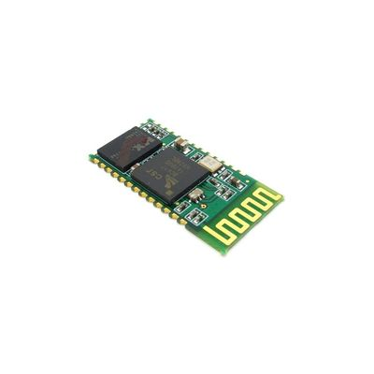

Figure.6

HC-06 module is an easy to use Bluetooth SPP (Serial Port Protocol) module, designed for transparent wireless serial connection setup.

Serial port Bluetooth module is fully qualified Bluetooth V2.0+EDR (Enhanced Data Rate) 3Mbps Modulation with complete 2.4GHz radio transceiver and baseband. It uses CSR Bluecore 04-External single chip Bluetooth system with CMOS technology and with AFH (Adaptive Frequency Hopping Feature). It has the footprint as small as 12.7mmx27mm. Hope it will simplify your overall design/development cycle.

**COMPONENTS NEEDED**

|  |  |  |
| --- | --- | --- |
| S.no | Components | Quantity |
| 1. | MQ135 Gas sensor | 1 |
| 2. | Arduino Nano | 1 |
| 3. | HC05 Bluetooth module | 1 |
| 4. | OLED (64*128) | 1 |
| 5. | 3.7V liPo Battery *2 | 2 |

Table.3

**HOW THE CIRCUIT WORKS**

As the device is powered, the Arduino board loads the required libraries, flashes some initial messages on the LCD screen and start sensing data from the MQ-135 sensor. The sensitivity curve of the sensor for different combustible gases is already mentioned above. The sensor can be calibrated so that its analog output voltage is proportional to the concentration of polluting gases in PPM. The analog voltage sensed at the pin A0 of the Arduino is converted to a digital value by using the in-built ADC channel of the Arduino. The Arduino board has 10-bit ADC channels, so the digitized value ranges from 0 to 1023. The digitized value can be assumed proportional to the concentration of gases in PPM. The read value is first displayed on LCD screen and passed to the bluetooth module wrapped in proper string through virtual serial function.  The bluetooth module is configured to connect with the Ubidots IOT platform. Ubidots is an IOT analytics platform service that allows to aggregate, visualize and analyze live data streams in the cloud. Ubidots provides instant visualizations of data posted by the IOT devices to . Ubidots server. With the ability to execute MATLAB code in . Ubidots one can perform online analysis and processing of the data as it comes in as shown in the figure below.

USER INTERFACE OF UBIDOTS PATFORM

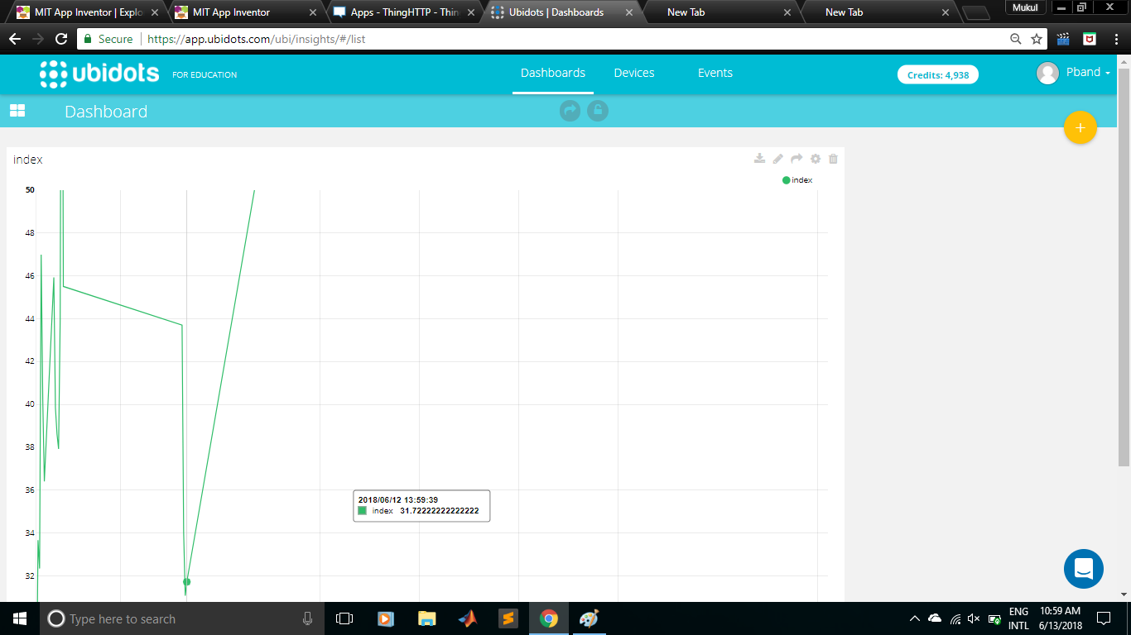

Figure.6

**Arduino Code**

The program code is intended to be loaded on an Arduino UNO. In the program code, first the standard open-source libraries of Arduino for interfacing LCD and setting up virtual serial communication are imported. This followed by declaration of variables representing the circuit connections of the Arduino with the character LCD, MQ-135 sensor and bluetoothmodule.The

API key is stored in a variable and objects of LCD and virtualserial type are instantiated.

#include <Adafruit_GFX.h>

#include <Adafruit_SSD1306.h>

// If using software SPI (the default case):

#define OLED_MOSI 9

#define OLED_CLK 10

#define OLED_DC 11

#define OLED_CS 12

#define OLED_RESET 13

Adafruit_SSD1306 display(OLED_MOSI, OLED_CLK, OLED_DC, OLED_RESET, OLED_CS);

/* Uncomment this block to use hardware SPI

#define OLED_DC 6

#define OLED_CS 7

#define OLED_RESET 8

Adafruit_SSD1306 display(OLED_DC, OLED_RESET, OLED_CS);

*/

#define NUMFLAKES 10

#define XPOS 0

#define YPOS 1

#define DELTAY 2

#define LOGO16_GLCD_HEIGHT 16

#define LOGO16_GLCD_WIDTH 16

static const unsigned char PROGMEM logo16_glcd_bmp[] =

{ B00000000, B11000000,

B00000001, B11000000,

B00000001, B11000000,

B00000011, B11100000,

B11110011, B11100000,

B11111110, B11111000,

B01111110, B11111111,

B00110011, B10011111,

B00011111, B11111100,

B00001101, B01110000,

B00011011, B10100000,

B00111111, B11100000,

B00111111, B11110000,

B01111100, B11110000,

B01110000, B01110000,

B00000000, B00110000 };

char ch;

char temp[7];

int h,m,s,flag;

void setup() {

// put your setup code here, to run once:

Serial.begin(9600);

display.begin(SSD1306_SWITCHCAPVCC); // Clear the buffer.

display.clearDisplay();

display.setTextSize(1);

display.setTextColor(WHITE);

display.setCursor(0,0);

display.print("Connect a device first");

do{

if(Serial.available()>0)

{

ch=Serial.read();

}

}while(ch!='*');

for(int m=0;m<6;m++)

{

while(!Serial.available());

if(Serial.available()>0)

{

temp[m]=Serial.read();

}

}

h=10*(temp[0]-48)+(temp[1]-48);

m=10*(temp[2]-48)+(temp[3]-48);

s=10*(temp[4]-48)+(temp[5]-48);

flag=h;

if(h>12)

{

h=h-12;

}

}

void loop() {

// put your main code here, to run repeatedly:

s=s+1;

display.setCursor(35,5);

display.print(h);

display.print(":");

display.print(m);

display.print(":");

display.print(s);

if(flag<12)display.println(" AM");

if(flag==12)display.println(" PM");

if(flag>12)display.println(" PM");

if(flag==24)flag=0;

display.display();

delay(950);

display.clearDisplay();

if(s==60){

s=0;

m=m+1;

}

if(m==60)

{

m=0;

h=h+1;

flag=flag+1;

}

if(h==13)

{

h=1;

}

int sensorValue= analogRead(A0);

Serial.println(sensorValue);

display.setCursor(0,15);

display.print("Air Quality index: ");

display.print(sensorValue);

display.display();

}

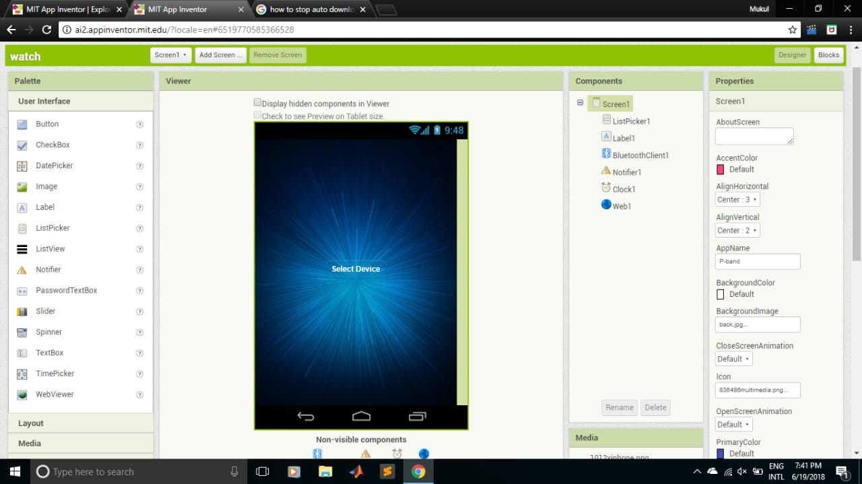  
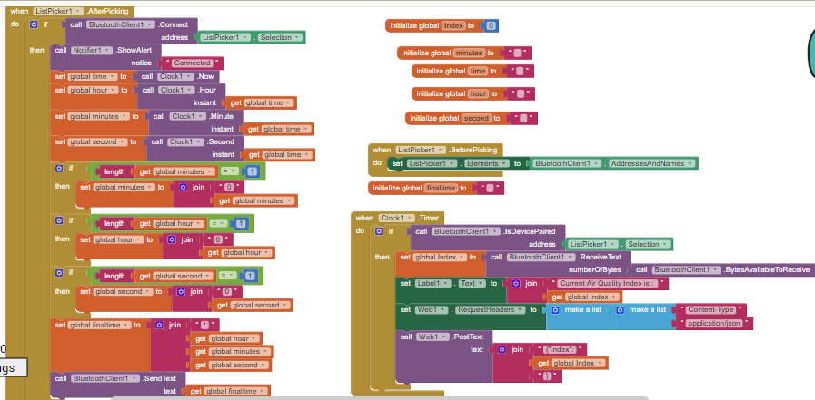

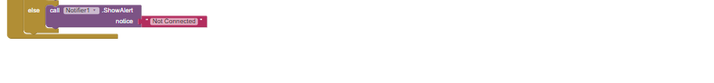

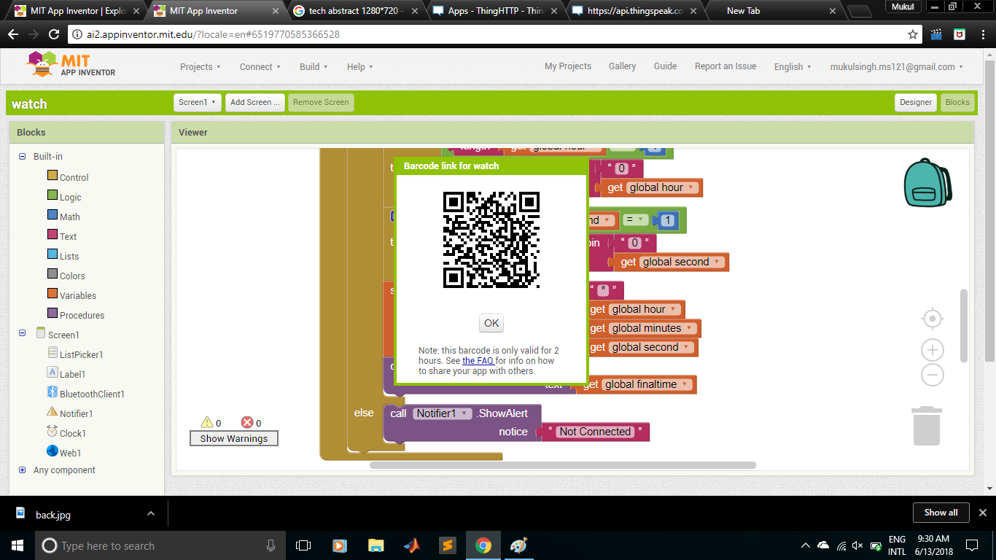

**CONCLUSION**

The system to monitor the air of environment using Arduino microcontroller, IOT Technology is proposed to improve quality of air. With the use of IOT technology enhances the process of monitoring various aspects of environment such as air quality monitoring issue proposed in this paper. Here the using of MQ135 gas sensor gives the sense of different type of dangerous gas and arduino is the heart of this project which controls the entire process. Bluetooth module connects the whole process to arduino and LCD is used for the visual Output. The air monitoring system overcomes the problem of the highly-polluted areas which is a major issue. It supports the new technology and effectively supports the healthy life concept. This system has features for the people to monitor the amount of pollution on their wrist band using the application.

**Project Links**

1. [www.youtube.com](http://www.youtube.com)
2. [www.instructsbles.com](http://www.instructsbles.com)
3. [www.google.co.in](http://www.google.co.in)
4. [www.circuitdigest.com](http://www.circuitdigest.com)
5. [www.arduino.cc](http://www.arduino.cc)